**Melina Yurie Mituo – 2020 February 13th**

**Introduction**

New York is the most populous city in the United States. Besides that, it is well known that New York is a place where many cultures cross each other due to its strong immigration back in the 19th and 20th century. Because of this, the cuisine of this amazing city comprises many cuisines belonging to various ethinic groups. No industry has borne more mandates from the drive to reduce inequality in the city than the restaurant industry. Today, there is over 27 thousand restaurants in the city and this number just keeps growing. Restaurants are a driving force in New York’s economy and they provide jobs and build careers for thousands of people, and play a vital role in local communities throughout the state. There are some data below:

* Restaurants and foodservice jobs represent 9% of the employment in the state
* 51.6 billion is the sales number estimated in New York

This report will be interesting for entrepreneurs who wants to open a restaurant in New York City. New York City can bring along a lot of the opportunities that this city can bring to the business in the future such as customers and providers. On the other hand, NY is a big city and has a lot of neighborhoods that have many peculiarities. I would like to know the best places to start my own Asian restaurant.

**Data and Methodology**

The data used on this project:

* List of Boroughs and neighborhoods of Manhattan with their geodata (latitud and longitud) - https://cocl.us/new_york_dataset
* Restaurants for each Manhattan/Brooklyn neighborhood - Foursquare
* NY Demographic data - https://data.cityofnewyork.us/api/views/swpk-hqdp/rows.csv?accessType=DOWNLOAD

The first list is responsible for getting us latitud and longitud to introduce into Foursquare to obtain restaurants data per neighborhood. After this, it is important to have a number of restaurants per person (demographic data) to know if the neighborhood is saturated of this business or not.

**Results and Discussion**

First, a dataframe of neighborhoods and their latitude and longitude was created.

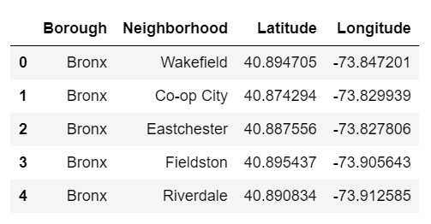

Second, another dataframe with neighborhood and their population was created.

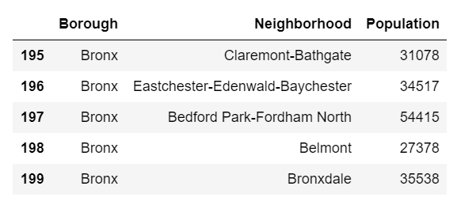

These two dataframes were merged to facilitate the work. Based on the latitud and longitud, it was possible to achieve many venues present in each neighborhood.

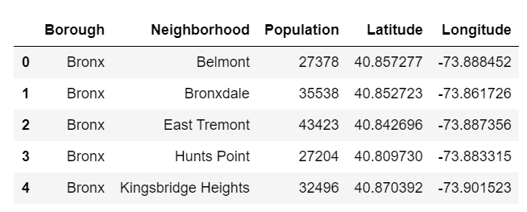

Then, a list of venues was created with the help of foursquare API.

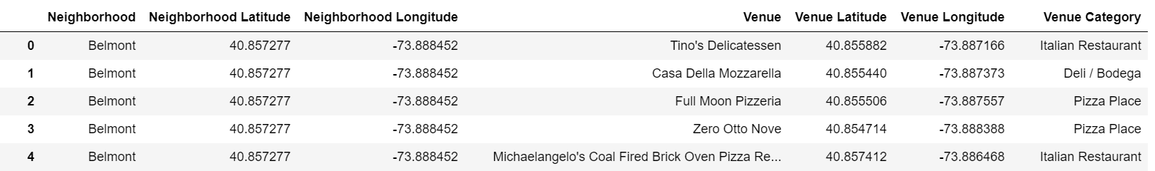

It was necessary to create a filter to obtain the Asians restaurants (Japanese, Korean, Chinese…) After this, the number of Asian restaurants per neighborhood was counted. The foursquare API has a limitation of venues that are returned, therefore is was necessary to upscale these number: the quantity of Asian restaurants in Chinatown was about 200 and the obtained by foursquare was 18. Then, a proportion relation was applied to each number of restaurants.

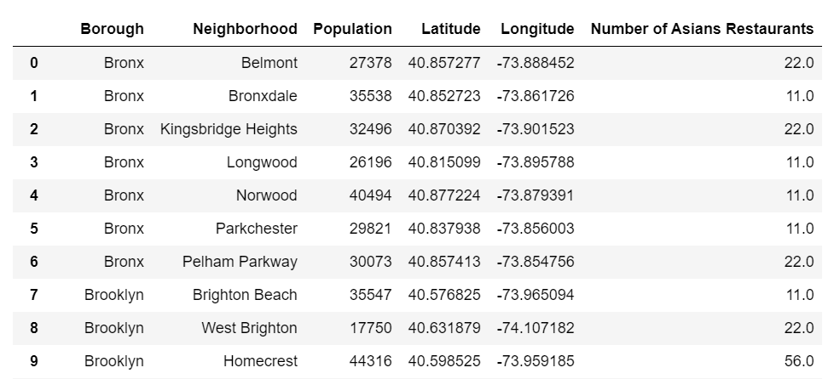

With these data, it was possible to divide the number of asian restaurants and the population of each neighborhood.

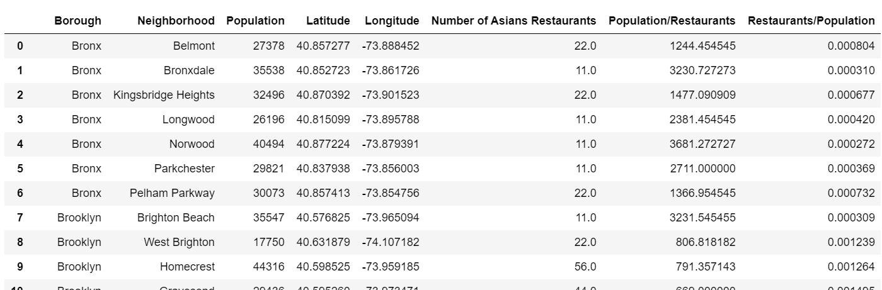

A filter was created: only Brooklyn and manhattan were considered to host the restaurant.

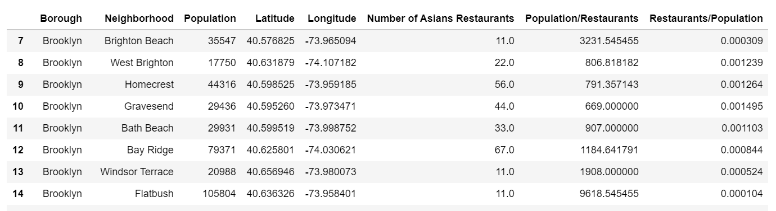

The table was sorted ascending by the last column and:

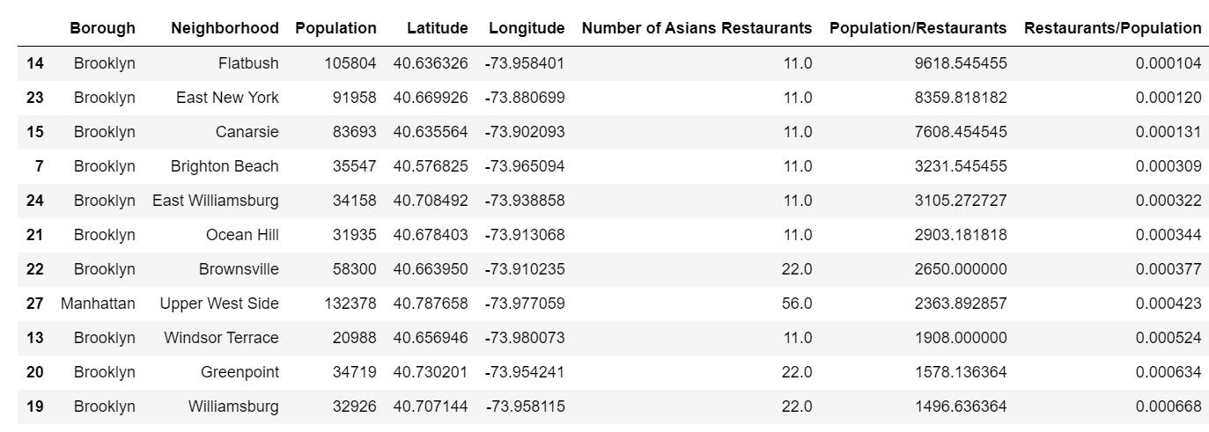

We can see that Brooklyn is less saturated of asian restaurants than manhattan. It was expected since Manhattan is the core of New York City, where the most of the food experiences are located. Despite the data, there are other factors such as rent, distance from the suppliers/providers, people circulation, etc..

**Conclusion**

The best neighborhood to open the restaurant is Flatbush, but some other factors were not included such as rent, people circulation, and it could be a direction to the investment, but it can’t be 100% confirmed.